Git Ignore Lab Instructions

## Step 1: Initialize a Git Repository

mkdir git-lab-project

cd git-lab-project

git init

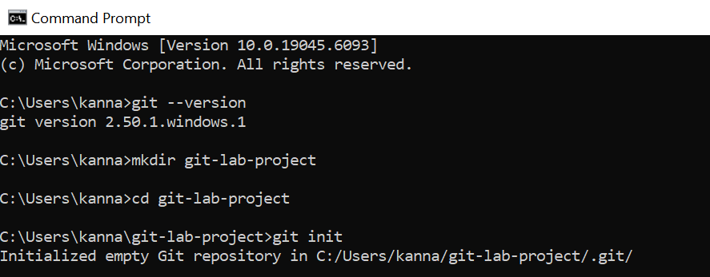

## Step 2: Create .log File and log Folder

echo.> sample.log

mkdir log

echo Test > log\test.log

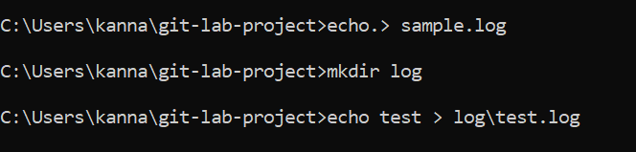

## Step 3: Create and Edit .gitignore File

echo.> .gitignore

notepad .gitignore

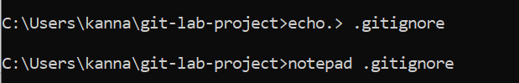

## (Inside Notepad, add the following lines to .gitignore)

*.log

log/

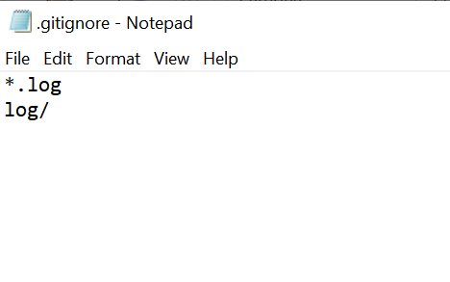

## Step 4: Check Git Status

git status

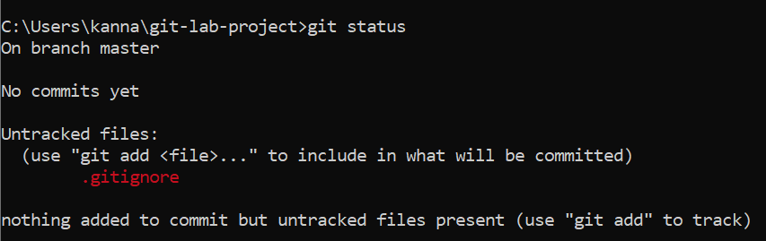

## Step 5: Commit .gitignore File

git add .gitignore

git commit -m "Ignore .log files and log folder"

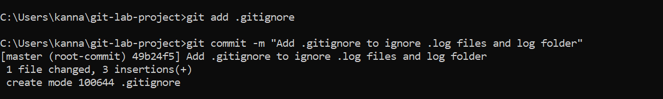

## Step 6: Verify Ignore Rules

git check-ignore -v sample.log

git check-ignore -v log\test.log



## Step 7: Final Git Status Check

git status

